travel mart guide

Transportation Vendor

July/2014 For Internal Distribution Only
Contents
Introduction 2
How to log-in 3
How to change your password 4
Understanding your Homepage 5
View data by Date 6
Export Manifest 6
Assigning crew members to a vehicle 7
How to confirm transportation for the sign offs 9
How to search through the crew manifest 10
How to view crewmember information 11

Introduction

Last updated: July,2014
Created by: Chiara van der Kwast
This manual is intended to be a guide to RCL Transportation companies who are using Travel Mart.
Travel Mart is a web based system created and managed by the Shipboard HR Strategy and Services of Royal Caribbean Cruises Ltd. This tool was designed to provide crewmember travel arrangements.
Save and print documents or itineraries, follow ongoing procedures by viewing remarks made by users and much more with Travel Mart.
For support or issues with the system, contact SHRSS_Support@rccl.com

How to log-in

Step 1: Go to Https://www.rclcrew.com
Step 2: Enter your Username and Password in the appropriate fields.
Step 3: Click on Log In
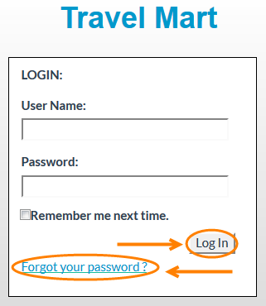
Note: If you are logging in for the first time, enter the username and password provided. Once you have logged in you will be prompted to change your password.
Forgot your password? Click on Forgot your password.
Enter your Username and you will receive and email with your password.
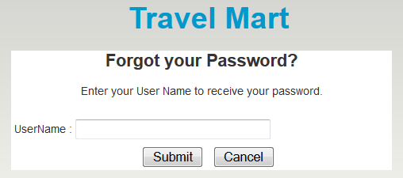

How to change your password

Step 1: At the top right corner of the screen, click on Change Password.
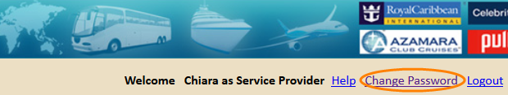
Step 2: In the field Password, enter your current password.
Step 3: In the field New password, enter the new password.
Step 4: Confirm your new password and click on Save.
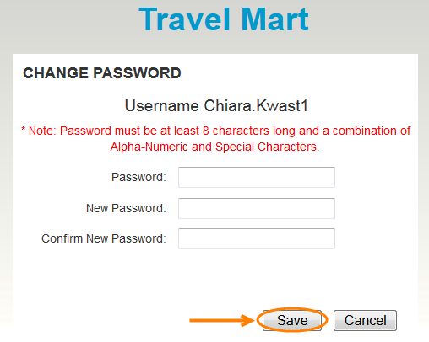

Note: Passwords are case sensitive and must be at least 8 characters long and a combination of Alpha-Numeric and Special Characters.

Understanding your Homepage
The homepage will display a list of crewmembers who need transportation services for the different routes you service.
- Filter information by clicking on the drop down menu next to Route From and Route To.
- If applicable filter information by clicking on the drop down menu next to City From and City To.
To view all crewmember information scroll back and forth. To view all crewmembers scroll up and down.
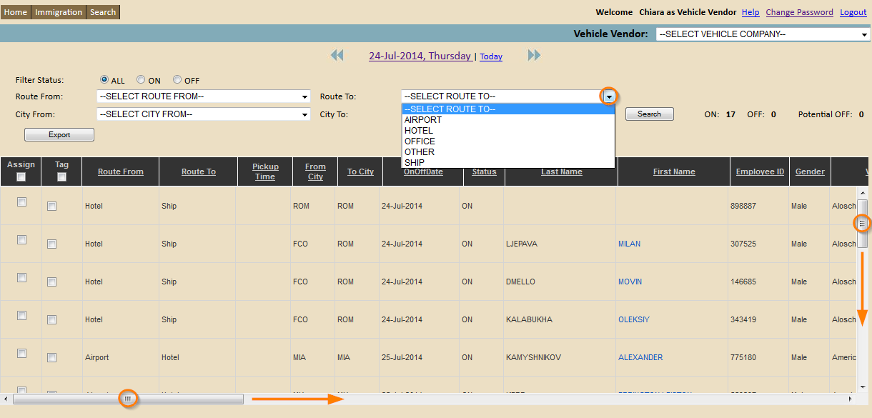
The system will default to the date you are signing in. See following if you wish to view data from a different date.

View data by Date

Step 1: Click on the date displayed at the top of the page. A calendar will appear. Or click on the arrows to go back and forth.
Step 2: Select the date you wish to view. A new screen will display details of sign on and off crewmembers for that selected day.
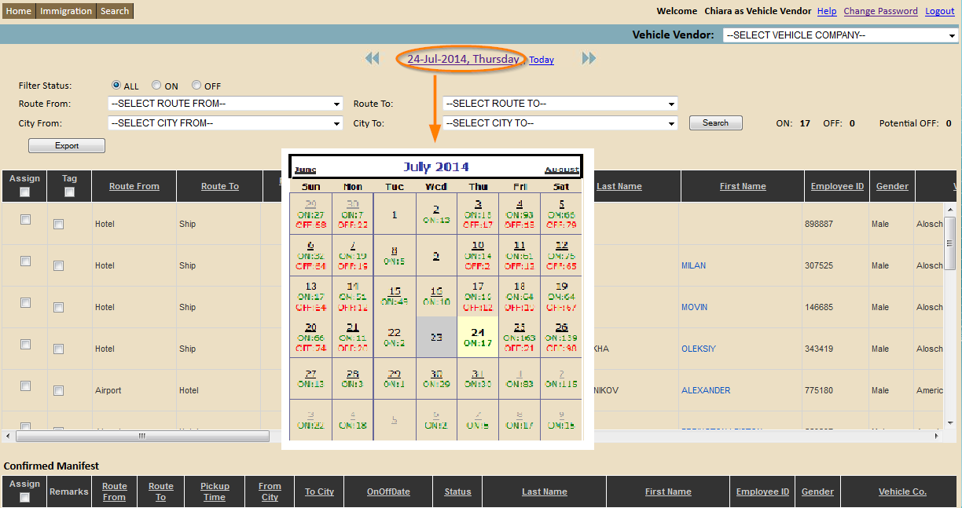

Export Manifest

Step 1: Once you have selected the date required, click on Export.
Step 2: Save the file as an XML file by clicking OK in the window that appears. Retrieve document in the download file.
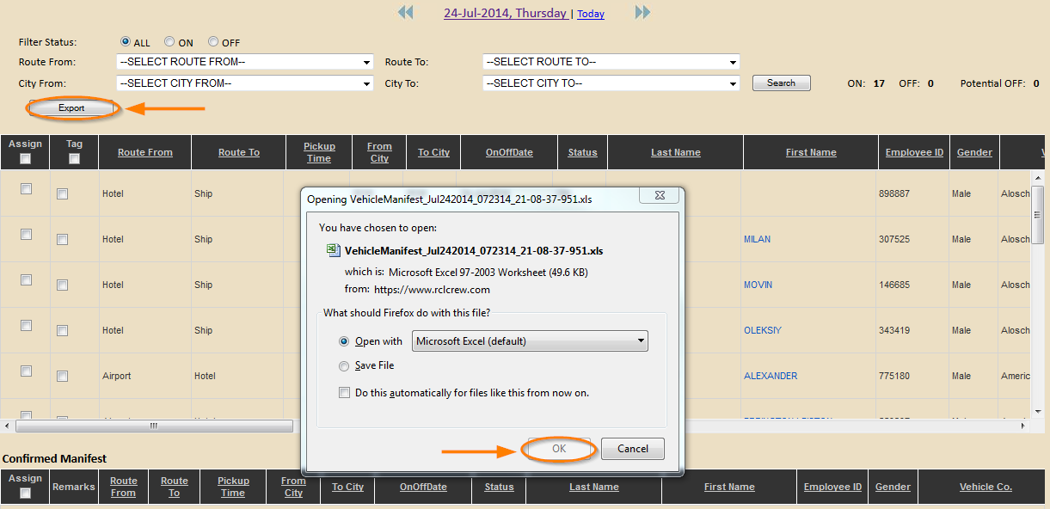

Assigning crew members to a vehicle
Step 1: Select the crewmembers by clicking on relevant check boxes (first column).
Step 2: Click on Confirm.
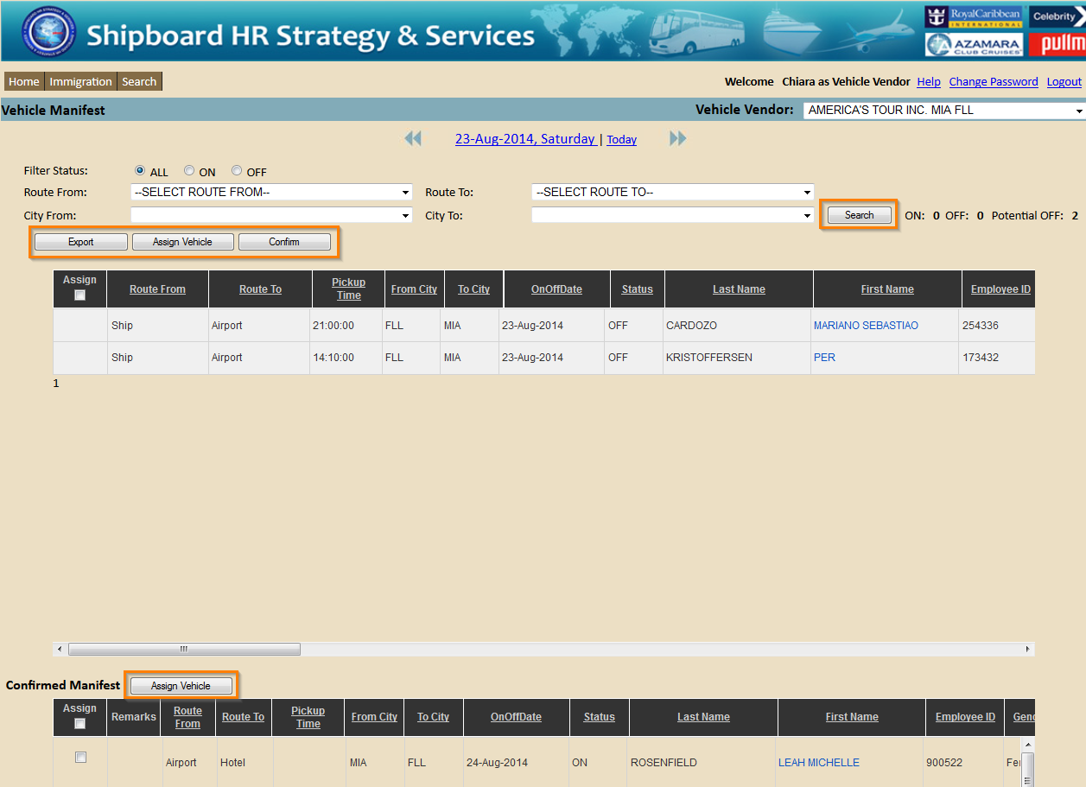
The crewmembers selected will now appear under the Confirmed Manifest. Scroll down to view this section
Step 3: Select the crewmembers by clicking on relevant check boxes (first column).
Step 4: Click on Assign Vehicle 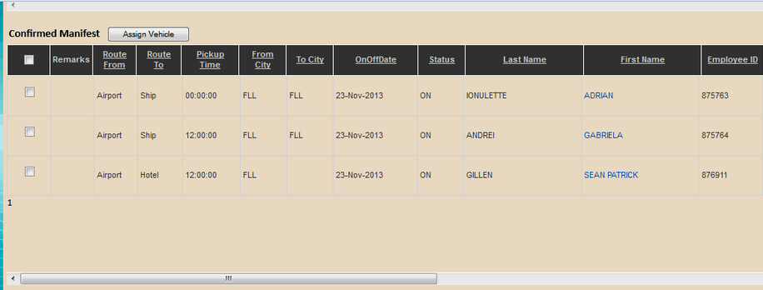
The following pop-up window will appear.
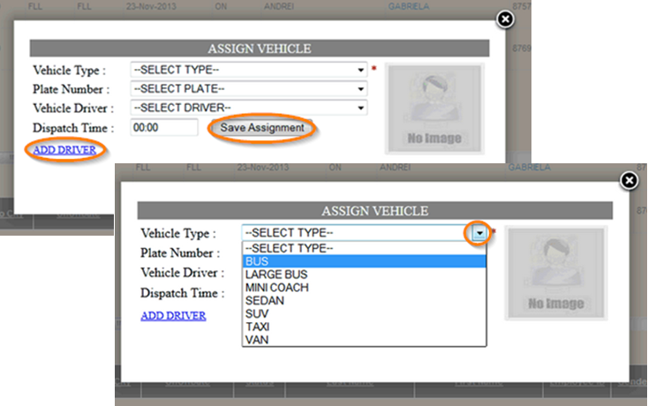
Step 5: Click on the drop down menu to select a Vehicle Type.
If available, select the Plate Number and the Vehicle Driver as well.
Step 6: Click on Save Assignment
Note: Using the Dispatch Time field is optional since this is only for your records and should not interfere with the pick-up time.
The assignment information will now appear on your Homepage under Confirmed Manifest.
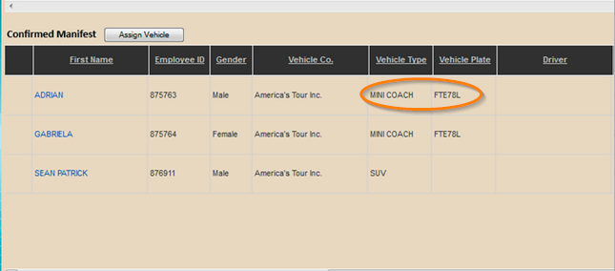

How to confirm transportation for the sign offs

Step 1: Select Route From: Ship, Route To: Airport.
Step 2: Select Route To: Airport or Hotel.
Note: Records will be grayed out until the Crew Admin confirms the Transportation pick-up time for the crewmembers.
Pickup time column now reflects the requested time by the crew admin. You will receive an email once the crew admin has confirmed the transportation. Crew Admins will confirm the transportation pick-up time for the sign offs 48 hours before the turn however you will have visibility to all possible sign offs 30 days prior.
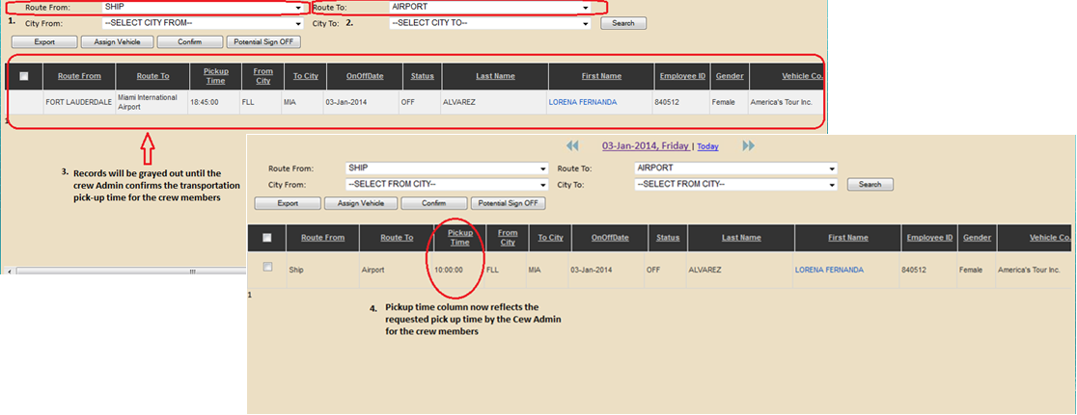
The following email notification will be sent to the sign offs.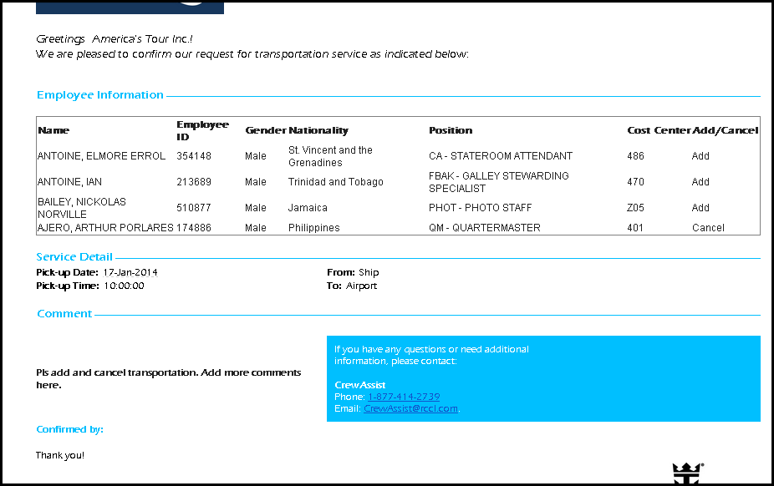

How to search through the crew manifest

To search through the entire crew manifest, follow these steps:
Step 1: On your homepage, click on the Search button in the top left. The Manifest Search Filter will display.
Step 2: Filter crewmember by entering the Employee ID, Last Name, First Name, and/or Record Locator. You can also filter by ship. Enter Code and/or Name of ship.
Step 3: Click on Search.
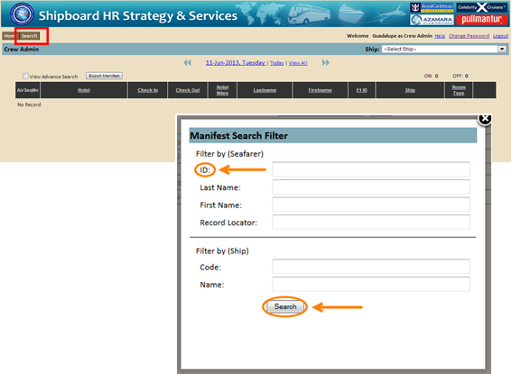
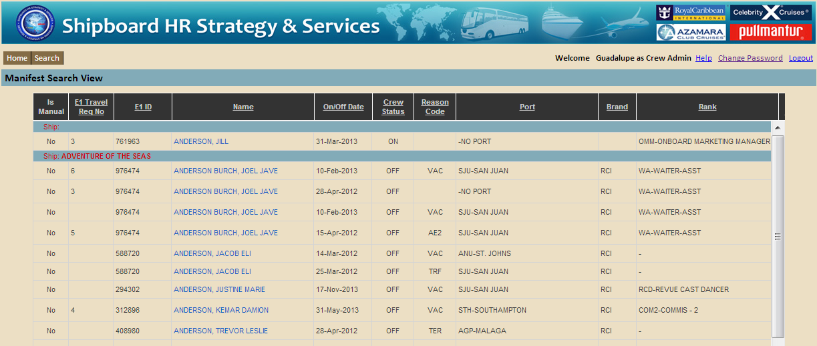
Note: Filtering by Employee ID would be the easiest way to find the correct data seeing as names can have similarities.

How to view crewmember information

Once you have found the correct data you can start reviewing the information visible to you.
On the first page you will be able to view future travel arrangements of the crewmember.
- Scroll back and forth to view all the information provided to you. The information that will be displayed is as follows; E1 Travel number, E1 ID, Name, On/Off Date, Crew Status, Reason Code, Port, Brand, Rank, Air Status, Vehicle Status, Hotel Status, Record Locator, Origin-Destination, Meet & Greet, Service Provider, Hotel vender, and Remarks.

Air, Vehicle, and Hotel status refers to if this service has been scheduled for this specific crewmember.
This sign indicates that this service has not been scheduled for this specific crewmember.
This sign indicates that this service has been scheduled for this specific crewmember.
- Select the View All box on the top left of the page to view past travel arrangements. The travel history will be shown in alphabetical order by ship not by date.

- Click on crewmember name (appears in blue). You will be redirected to a page with more detailed information about the crewmember and travel arrangements.
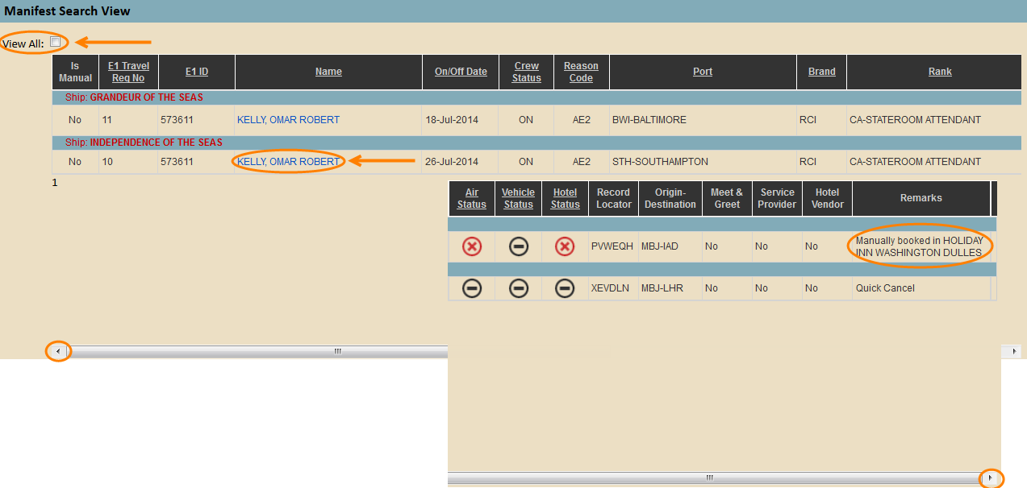
Note: Remarks displayed on the right side of the column are automatically plugged in when changes are made.

You will be able to view: E1 ID, Name, Nationality, Gender, Brand, Ship, Rank, Reason Code, Status, Signing ON Date, Signing OFF Date, and Origin/destination.
All other information is as follows: Air Travel, Vehicle, and Port information.
